# ART GALLERY MANAGEMENT SYSTEM

Project by – miss. Pooja Mahendra Malusare.

GUIDED BY – Mr. SAMIR WARSOLKAR SIR.

**ABSTRACT**

The Art Gallery Management System in MySQL offers a comprehensive solution for organizing and managing artworks, artists, and customer interactions. By seamlessly integrating functionalities such as artist and artwork management, customer tracking, and transaction recording, it streamlines gallery operations while providing insights into sales performance and customer preferences. This project harnesses the power of MySQL to create an efficient and user-friendly platform for art galleries to enhance their operations and customer experiences.

POOJA MAHENDRA MALUSARE

[Poojamalusare29@gmail.com](mailto:Poojamalusare29@gmail.com)

**ART GALLERY MANAGEMENT SYSTEM**

Project for SQL Module

**Description**:

The Art Gallery Management System is designed to facilitate the management of an art gallery's operations, including artist and artwork management, customer interactions, and transaction tracking. The system maintains comprehensive records of artists, their artworks, customers, images of artworks, and transactions.

**Features**:-

1. Artist Management:

The system allows administrators to maintain records of artists, including their names, dates of birth, nationalities, and other relevant information.

1. Artwork Management:

Artworks created by artists are recorded in the system, including details such as titles, mediums, years created, prices, and availability status (e.g., available for sale, sold, on loan).

1. Customer Management:

Customers interested in purchasing artworks are registered in the system, with their names, contact information (email, phone number, address), and membership status (e.g., regular, premium, VIP).

1. Image Management:

Images of artworks are stored in the system to showcase them to customers. Each artwork can have multiple images associated with it.

1. Transaction Tracking:

The system tracks transactions made by customers, including the purchase of artworks. Each transaction records the customer involved, the artwork purchased, the transaction date, amount, and payment method.

ER-Diagram (Entity Relation – Diagram) for Art Gallery Management System :-

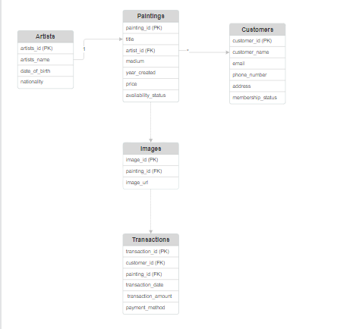

**Table Descriptions :-**

1. Artists :-

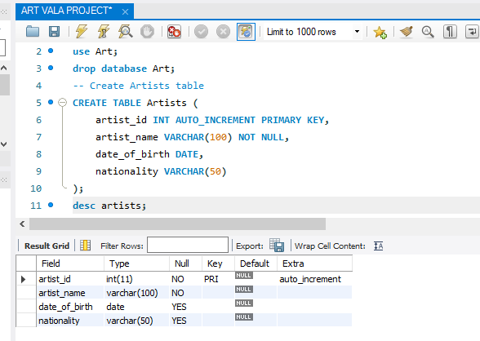

1. Paintings :-

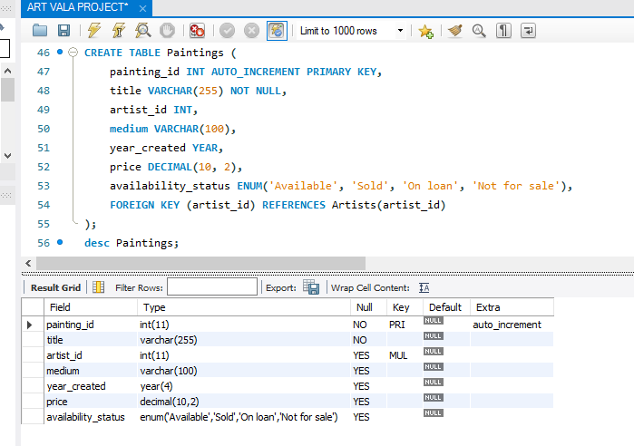

1. Customers :-

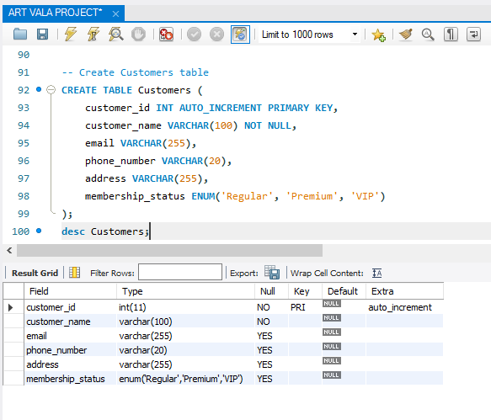

1. Images :-

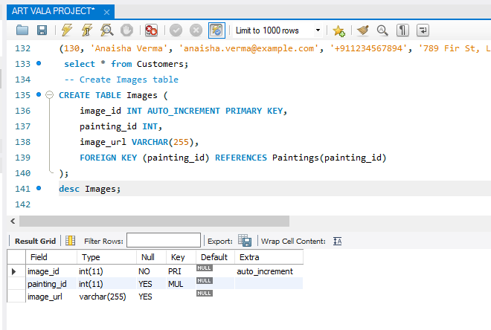

1. Transactions:- 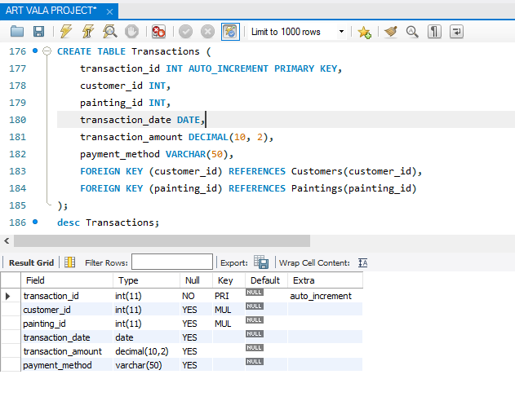

create database Art;

use Art;

drop database Art;

-- Create Artists table

CREATE TABLE Artists (

artist_id INT AUTO_INCREMENT PRIMARY KEY,

artist_name VARCHAR(100) NOT NULL,

date_of_birth DATE,

nationality VARCHAR(50)

);

desc artists;

-- Insert rows for Indian artists

INSERT INTO Artists (artist_id, artist_name, date_of_birth, nationality) VALUES

(1, 'Raja Ravi Varma', '1848-04-29', 'Indian'),

(2, 'Amrita Sher-Gil', '1913-01-30', 'Indian'),

(3, 'Tyeb Mehta', '1925-07-25', 'Indian'),

(4, 'Francis Newton Souza', '1924-04-12', 'Indian'),

(5, 'M.F. Husain', '1915-09-17', 'Indian'),

(6, 'S.H. Raza', '1922-02-22', 'Indian'),

(7, 'Vasudeo S. Gaitonde', '1924-04-04', 'Indian'),

(8, 'Anish Kapoor', '1954-03-12', 'Indian'),

(9, 'Bhupen Khakhar', '1934-03-10', 'Indian'),

(10, 'F.N. Souza', '1924-04-12', 'Indian'),

(11, 'Arun Kumar H.G.', '1975-09-05', 'Indian'),

(12, 'G. Subramanian', '1929-07-05', 'Indian'),

(13, 'Gopal Ghose', '1913-03-09', 'Indian'),

(14, 'Jamini Roy', '1887-04-11', 'Indian'),

(15, 'Jogen Chowdhury', '1939-02-16', 'Indian'),

(16, 'K.G. Subramanyan', '1924-02-15', 'Indian'),

(17, 'Manjit Bawa', '1941-03-15', 'Indian'),

(18, 'M.F. Husain', '1915-09-17', 'Indian'),

(19, 'Meera Mukherjee', '1928-10-06', 'Indian'),

(20, 'Nandalal Bose', '1882-12-03', 'Indian'),

(21, 'Ram Kumar', '1924-09-23', 'Indian'),

(22, 'Rameshwar Broota', '1941-07-25', 'Indian'),

(23, 'Ramkinkar Baij', '1906-05-26', 'Indian'),

(24, 'S.H. Raza', '1922-02-22', 'Indian'),

(25, 'Sakti Burman', '1935-11-09', 'Indian'),

(26, 'Sohan Qadri', '1932-11-02', 'Indian'),

(27, 'Subodh Gupta', '1964-09-22', 'Indian'),

(28, 'Tayeb Mehta', '1925-07-25', 'Indian'),

(29, 'Thota Vaikuntam', '1942-05-23', 'Indian');

select * from Artists;

-- Create Paintings table

CREATE TABLE Paintings (

painting_id INT AUTO_INCREMENT PRIMARY KEY,

title VARCHAR(255) NOT NULL,

artist_id INT,

medium VARCHAR(100),

year_created YEAR,

price DECIMAL(10, 2),

availability_status ENUM('Available', 'Sold', 'On loan', 'Not for sale'),

FOREIGN KEY (artist_id) REFERENCES Artists(artist_id)

);

desc Paintings;

-- Insert rows for Indian paintings with associated artist IDs

INSERT INTO Paintings (painting_id, title, artist_id, medium, year_created, price, availability_status) VALUES

(1, 'Lady with the Lamp', 1, 'Oil on canvas', 1879, 100000.00, 'Available'),

(2, 'Self Portrait', 2, 'Oil on canvas', 1931, 1500000.00, 'Available'),

(3, 'Kali', 3, 'Oil on canvas', 1989, 800000.00, 'Available'),

(4, 'Birth', 4, 'Oil on canvas', 1963, 1200000.00, 'Sold'),

(5, 'Zameen', 5, 'Oil on canvas', 1980, 1800000.00, 'Available'),

(6, 'Bindu', 6, 'Oil on canvas', 1987, 2500000.00, 'Available'),

(7, 'Untitled', 7, 'Oil on canvas', 1968, 3000000.00, 'On loan'),

(8, 'Sky Mirror', 8, 'Stainless steel', 2006, 3500000.00, 'Not for sale'),

(9, 'Bharat Mata', 9, 'Oil on canvas', 1993, 4000000.00, 'Available'),

(10, 'Mahishasura', 10, 'Oil on canvas', 1960, 500000.00, 'Sold'),

(11, 'The Cosmic Dance', 11, 'Oil on canvas', 1971, 12000000.00, 'Available'),

(12, 'Divine Lovers', 12, 'Oil on canvas', 1957, 12000000.00, 'Available'),

(13, 'Santiniketan', 13, 'Watercolor', 1950, 900000.00, 'Available'),

(14, 'Mother and Child', 14, 'Oil on canvas', 1946, 800000.00, 'Sold'),

(15, 'Untitled', 15, 'Oil on canvas', 1982, 700000.00, 'Available'),

(16, 'The Battle of Ganga and Jamuna', 16, 'Oil on canvas', 1971, 6000000.00, 'Available'),

(17, 'Nude', 17, 'Oil on canvas', 1959, 2000000.00, 'Available'),

(18, 'Shakti', 18, 'Oil on canvas', 1960, 3000000.00, 'On loan'),

(19, 'Ganesha', 19, 'Oil on canvas', 1955, 800000.00, 'Available'),

(20, 'Mother and Child', 20, 'Bronze', 1959, 500000.00, 'Available'),

(21, 'Untitled', 21, 'Oil on canvas', 1965, 600000.00, 'Sold'),

(22, 'Varanasi', 22, 'Oil on canvas', 1951, 1200000.00, 'Available'),

(23, 'Wounds', 23, 'Oil on canvas', 1974, 3500000.00, 'Available'),

(24, 'Adi Parva', 24, 'Oil on canvas', 1971, 2500000.00, 'Available'),

(25, 'The Last Supper', 25, 'Oil on canvas', 1980, 3000000.00, 'Not for sale'),

(26, 'Shiva', 26, 'Oil on canvas', 1969, 1500000.00, 'Available'),

(27, 'Untitled', 27, 'Oil on canvas', 1988, 1800000.00, 'Available'),

(28, 'Untitled', 28, 'Oil on canvas', 1976, 800000.00, 'Available'),

(29, 'Man With His Bull', 29, 'Bronze', 1972, 500000.00, 'Available');

select * from Paintings;

-- Create Customers table

CREATE TABLE Customers (

customer_id INT AUTO_INCREMENT PRIMARY KEY,

customer_name VARCHAR(100) NOT NULL,

email VARCHAR(255),

phone_number VARCHAR(20),

address VARCHAR(255),

membership_status ENUM('Regular', 'Premium', 'VIP')

);

desc Customers;

-- Insert rows for Indian customers

INSERT INTO Customers (customer_id, customer_name, email, phone_number, address, membership_status) VALUES

(101, 'Rahul Sharma', 'rahul.sharma@example.com', '+911234567890', '123 Main St, Delhi', 'Regular'),

(102, 'Priya Patel', 'priya.patel@example.com', '+919876543210', '456 Elm St, Mumbai', 'Premium'),

(103, 'Rajesh Singh', 'rajesh.singh@example.com', '+911122334455', '789 Oak St, Kolkata', 'Regular'),

(104, 'Kavita Gupta', 'kavita.gupta@example.com', '+911234567890', '987 Maple St, Bangalore', 'VIP'),

(105, 'Amit Kumar', 'amit.kumar@example.com', '+919988776655', '654 Pine St, Chennai', 'Regular'),

(106, 'Anjali Reddy', 'anjali.reddy@example.com', '+919900990099', '321 Cedar St, Hyderabad', 'Regular'),

(107, 'Sandeep Mishra', 'sandeep.mishra@example.com', '+911234567890', '234 Birch St, Pune', 'Regular'),

(108, 'Neha Malhotra', 'neha.malhotra@example.com', '+919876543210', '567 Walnut St, Jaipur', 'Premium'),

(109, 'Suresh Shah', 'suresh.shah@example.com', '+911122334455', '876 Spruce St, Ahmedabad', 'Regular'),

(110, 'Divya Verma', 'divya.verma@example.com', '+911234567890', '789 Fir St, Lucknow', 'Regular'),

(111, 'Vikram Patel', 'vikram.patel@example.com', '+919988776655', '543 Pine St, Chandigarh', 'Regular'),

(112, 'Priyanka Gupta', 'priyanka.gupta@example.com', '+919900990099', '345 Cedar St, Nagpur', 'Regular'),

(113, 'Arun Singh', 'arun.singh@example.com', '+911234567890', '876 Birch St, Indore', 'Regular'),

(114, 'Meera Joshi', 'meera.joshi@example.com', '+919876543210', '234 Elm St, Varanasi', 'VIP'),

(115, 'Sanjay Sharma', 'sanjay.sharma@example.com', '+911122334455', '567 Oak St, Bhopal', 'Regular'),

(116, 'Deepak Gupta', 'deepak.gupta@example.com', '+911234567890', '987 Maple St, Surat', 'Regular'),

(117, 'Sunita Devi', 'sunita.devi@example.com', '+919988776655', '321 Cedar St, Kanpur', 'Regular'),

(118, 'Rajiv Kumar', 'rajiv.kumar@example.com', '+919900990099', '654 Pine St, Patna', 'Regular'),

(119, 'Pooja Yadav', 'pooja.yadav@example.com', '+911234567890', '876 Spruce St, Jaipur', 'Regular'),

(120, 'Aarav Gupta', 'aarav.gupta@example.com', '+911234567891', '123 Main St, Delhi', 'Regular'),

(121, 'Ishaan Sharma', 'ishaan.sharma@example.com', '+919876543212', '456 Elm St, Mumbai', 'Premium'),

(123, 'Aanya Singh', 'aanya.singh@example.com', '+911122334456', '789 Oak St, Kolkata', 'Regular'),

(124, 'Advika Patel', 'advika.patel@example.com', '+911234567892', '987 Maple St, Bangalore', 'VIP'),

(125, 'Vivaan Kumar', 'vivaan.kumar@example.com', '+919988776656', '654 Pine St, Chennai', 'Regular'),

(126, 'Aadhya Reddy', 'aadhya.reddy@example.com', '+919900990098', '321 Cedar St, Hyderabad', 'Regular'),

(127, 'Vihaan Mishra', 'vihaan.mishra@example.com', '+911234567893', '234 Birch St, Pune', 'Regular'),

(128, 'Ritisha Malhotra', 'ritisha.malhotra@example.com', '+919876543213', '567 Walnut St, Jaipur', 'Premium'),

(129, 'Aarush Shah', 'aarush.shah@example.com', '+911122334457', '876 Spruce St, Ahmedabad', 'Regular'),

(130, 'Anaisha Verma', 'anaisha.verma@example.com', '+911234567894', '789 Fir St, Lucknow', 'Regular');

select * from Customers;

-- Create Images table

CREATE TABLE Images (

image_id INT AUTO_INCREMENT PRIMARY KEY,

painting_id INT,

image_url VARCHAR(255),

FOREIGN KEY (painting_id) REFERENCES Paintings(painting_id)

);

desc Images;

-- Insert rows for Indian paintings into the Images table

INSERT INTO Images (painting_id, image_url) VALUES

(1, 'https://example.com/painting1.jpg'),

(2, 'https://example.com/painting2.jpg'),

(3, 'https://example.com/painting3.jpg'),

(4, 'https://example.com/painting4.jpg'),

(5, 'https://example.com/painting5.jpg'),

(6, 'https://example.com/painting6.jpg'),

(7, 'https://example.com/painting7.jpg'),

(8, 'https://example.com/painting8.jpg'),

(9, 'https://example.com/painting9.jpg'),

(10, 'https://example.com/painting10.jpg'),

(11, 'https://example.com/painting11.jpg'),

(12, 'https://example.com/painting12.jpg'),

(13, 'https://example.com/painting13.jpg'),

(14, 'https://example.com/painting14.jpg'),

(15, 'https://example.com/painting15.jpg'),

(16, 'https://example.com/painting16.jpg'),

(17, 'https://example.com/painting17.jpg'),

(18, 'https://example.com/painting18.jpg'),

(19, 'https://example.com/painting19.jpg'),

(20, 'https://example.com/painting20.jpg'),

(21, 'https://example.com/painting21.jpg'),

(22, 'https://example.com/painting22.jpg'),

(23, 'https://example.com/painting23.jpg'),

(24, 'https://example.com/painting24.jpg'),

(25, 'https://example.com/painting25.jpg'),

(26, 'https://example.com/painting26.jpg'),

(27, 'https://example.com/painting27.jpg'),

(28, 'https://example.com/painting28.jpg'),

(29, 'https://example.com/painting29.jpg');

select * from Images;

CREATE TABLE Transactions (

transaction_id INT AUTO_INCREMENT PRIMARY KEY,

customer_id INT,

painting_id INT,

transaction_date DATE,

transaction_amount DECIMAL(10, 2),

payment_method VARCHAR(50),

FOREIGN KEY (customer_id) REFERENCES Customers(customer_id),

FOREIGN KEY (painting_id) REFERENCES Paintings(painting_id)

);

desc Transactions;

-- Insert rows into the Transactions table with Indian names

INSERT INTO Transactions (customer_id, painting_id, transaction_date, transaction_amount, payment_method) VALUES

(101, 1, '2024-01-01', 1500.00, 'Credit Card'),

(102, 2, '2024-01-02', 2000.00, 'PayPal'),

(103, 3, '2024-01-03', 1800.00, 'Cash'),

(104, 4, '2024-01-04', 2200.00, 'Credit Card'),

(105, 5, '2024-01-05', 2500.00, 'PayPal'),

(106, 6, '2024-01-06', 1900.00, 'Cash'),

(107, 7, '2024-01-07', 2100.00, 'Credit Card'),

(108, 8, '2024-01-08', 1800.00, 'PayPal'),

(109, 9, '2024-01-09', 2000.00, 'Cash'),

(110, 10, '2024-01-10', 2300.00, 'Credit Card'),

(111, 11, '2024-01-11', 2200.00, 'PayPal'),

(112, 12, '2024-01-12', 2400.00, 'Cash'),

(113, 13, '2024-01-13', 2600.00, 'Credit Card'),

(114, 14, '2024-01-14', 1800.00, 'PayPal'),

(115, 15, '2024-01-15', 2100.00, 'Cash'),

(116, 16, '2024-01-16', 2200.00, 'Credit Card'),

(117, 17, '2024-01-17', 2300.00, 'PayPal'),

(118, 18, '2024-01-18', 2500.00, 'Cash'),

(119, 19, '2024-01-19', 2600.00, 'Credit Card'),

(120, 20, '2024-01-20', 2000.00, 'PayPal'),

(121, 21, '2024-01-21', 1800.00, 'Cash'),

(123, 22, '2024-01-22', 2100.00, 'Credit Card'),

(124, 23, '2024-01-23', 2200.00, 'PayPal'),

(125, 24, '2024-01-24', 2300.00, 'Cash'),

(126, 25, '2024-01-25', 2400.00, 'Credit Card'),

(127, 26, '2024-01-26', 2500.00, 'PayPal'),

(128, 27, '2024-01-27', 2600.00, 'Cash'),

(129, 28, '2024-01-28', 2700.00, 'Credit Card'),

(130, 29, '2024-01-29', 2800.00, 'PayPal');

select * from Transactions;

**SUBQUERIES :-**

1. Count Paintings by Artist:-

Query:-

SELECT artist_name, (SELECT COUNT(*) FROM Paintings WHERE artist_id = Artists.artist_id) AS num_paintings

FROM Artists;

Result :-

|  |  |
| --- | --- |
| artist_name | num_paintings |
| Raja Ravi Varma | 1 |
| Amrita Sher-Gil | 1 |
| Tyeb Mehta | 1 |
| Francis Newton Souza | 1 |
| M.F. Husain | 1 |
| S.H. Raza | 1 |
| Vasudeo S. Gaitonde | 1 |
| Anish Kapoor | 1 |
| Bhupen Khakhar | 1 |
| F.N. Souza | 1 |
| Arun Kumar H.G. | 1 |
| G. Subramanian | 1 |
| Gopal Ghose | 1 |
| Jamini Roy | 1 |
| Jogen Chowdhury | 1 |
| K.G. Subramanyan | 1 |
| Manjit Bawa | 1 |
| M.F. Husain | 1 |
| Meera Mukherjee | 1 |
| Nandalal Bose | 1 |
| Ram Kumar | 1 |
| Rameshwar Broota | 1 |
| Ramkinkar Baij | 1 |
| S.H. Raza | 1 |
| Sakti Burman | 1 |
| Sohan Qadri | 1 |
| Subodh Gupta | 1 |
| Tayeb Mehta | 1 |
| Thota Vaikuntam | 1 |

1. List Customers with Premium Membership:

Query :-

SELECT *

FROM Customers

WHERE membership_status = 'Premium';

Result :-

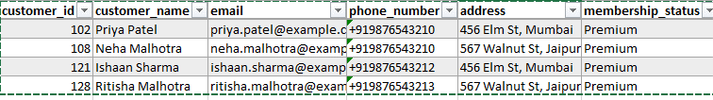

3. List Artists with Paintings Sold for more than Average Price:

Query :-

SELECT * FROM Artists

WHERE artist_id IN (SELECT artist_id FROM Paintings WHERE price > (SELECT AVG(price) FROM Paintings));

Result :-

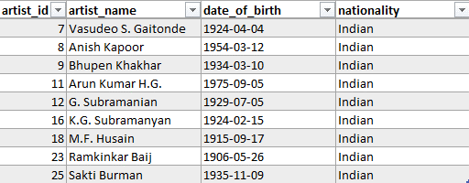

4. List Paintings with the Highest Price:

Query:-

SELECT * FROM Paintings

WHERE price = (SELECT MAX(price) FROM Paintings);

Result:-



5. Count Number of Transactions for Each Customer:

Query:-

SELECT customer_id, customer_name,

(SELECT COUNT(*) FROM Transactions WHERE customer_id = Customers.customer_id) AS num_transactions

FROM Customers;

Result:-

|  |  |  |
| --- | --- | --- |
| **Customer_id** | **customer_name** | **num_transactions** |
| 101 | Rahul Sharma | 1 |
| 102 | Priya Patel | 1 |
| 103 | Rajesh Singh | 1 |
| 104 | Kavita Gupta | 1 |
| 105 | Amit Kumar | 1 |
| 106 | Anjali Reddy | 1 |
| 107 | Sandeep Mishra | 1 |
| 108 | Neha Malhotra | 1 |
| 109 | Suresh Shah | 1 |
| 110 | Divya Verma | 1 |
| 111 | Vikram Patel | 1 |
| 112 | Priyanka Gupta | 1 |
| 113 | Arun Singh | 1 |
| 114 | Meera Joshi | 1 |
| 115 | Sanjay Sharma | 1 |
| 116 | Deepak Gupta | 1 |
| 117 | Sunita Devi | 1 |
| 118 | Rajiv Kumar | 1 |
| 119 | Pooja Yadav | 1 |
| 120 | Aarav Gupta | 1 |
| 121 | Ishaan Sharma | 1 |
| 123 | Aanya Singh | 1 |
| 124 | Advika Patel | 1 |
| 125 | Vivaan Kumar | 1 |
| 126 | Aadhya Reddy | 1 |
| 127 | Vihaan Mishra | 1 |
| 128 | Ritisha Malhotra | 1 |
| 129 | Aarush Shah | 1 |
| 130 | Anaisha Verma | 1 |

1. -- JOINS

-- List Artists with the Highest Number of Paintings:-

Query :-

SELECT artist_name, (SELECT COUNT(*) FROM Paintings WHERE artist_id = Artists.artist_id) AS num_paintings

FROM Artists

ORDER BY num_paintings DESC

Limit 10;

Result :-

|  |  |
| --- | --- |
| artist_name | num_paintings |
| Thota Vaikuntam | 1 |
| F.N. Souza | 1 |
| Bhupen Khakhar | 1 |
| Anish Kapoor | 1 |
| Vasudeo S. Gaitonde | 1 |
| S.H. Raza | 1 |
| M.F. Husain | 1 |
| Francis Newton Souza | 1 |
| Tyeb Mehta | 1 |
| Amrita Sher-Gil | 1 |

7. List Paintings with their Artists' Nationalities:

Query :-

SELECT p.title AS painting_title, a.nationality AS artist_nationality

FROM Paintings p

INNER JOIN Artists a ON p.artist_id = a.artist_id;

Result:-

|  |  |
| --- | --- |
| painting_title | artist_nationality |
| Lady with the Lamp | Indian |
| Self Portrait | Indian |
| Kali | Indian |
| Birth | Indian |
| Zameen | Indian |
| Bindu | Indian |
| Untitled | Indian |
| Sky Mirror | Indian |
| Bharat Mata | Indian |
| Mahishasura | Indian |
| The Cosmic Dance | Indian |
| Divine Lovers | Indian |
| Santiniketan | Indian |
| Mother and Child | Indian |
| Untitled | Indian |
| The Battle of Ganga and Jamuna | Indian |
| Nude | Indian |
| Shakti | Indian |
| Ganesha | Indian |
| Mother and Child | Indian |
| Untitled | Indian |
| Varanasi | Indian |
| Wounds | Indian |
| Adi Parva | Indian |
| The Last Supper | Indian |
| Shiva | Indian |
| Untitled | Indian |
| Untitled | Indian |
| Man With His Bull | Indian |

8. List Customers with their Membership Status and Transaction Amounts:

Query :-

SELECT c.customer_name, c.membership_status, t.transaction_amount

FROM Customers c

LEFT JOIN Transactions t ON c.customer_id = t.customer_id;

Result :-

|  |  |  |
| --- | --- | --- |
| **customer_name** | **membership_status** | **transaction_amount** |
| Rahul Sharma | Regular | 1500 |
| Priya Patel | Premium | 2000 |
| Rajesh Singh | Regular | 1800 |
| Kavita Gupta | VIP | 2200 |
| Amit Kumar | Regular | 2500 |
| Anjali Reddy | Regular | 1900 |
| Sandeep Mishra | Regular | 2100 |
| Neha Malhotra | Premium | 1800 |
| Suresh Shah | Regular | 2000 |
| Divya Verma | Regular | 2300 |
| Vikram Patel | Regular | 2200 |
| Priyanka Gupta | Regular | 2400 |
| Arun Singh | Regular | 2600 |
| Meera Joshi | VIP | 1800 |
| Sanjay Sharma | Regular | 2100 |
| Deepak Gupta | Regular | 2200 |
| Sunita Devi | Regular | 2300 |
| Rajiv Kumar | Regular | 2500 |
| Pooja Yadav | Regular | 2600 |
| Aarav Gupta | Regular | 2000 |
| Ishaan Sharma | Premium | 1800 |
| Aanya Singh | Regular | 2100 |
| Advika Patel | VIP | 2200 |
| Vivaan Kumar | Regular | 2300 |
| Aadhya Reddy | Regular | 2400 |
| Vihaan Mishra | Regular | 2500 |
| Ritisha Malhotra | Premium | 2600 |
| Aarush Shah | Regular | 2700 |
| Anaisha Verma | Regular | 2800 |

9. List Artists with the Titles of their Paintings and Transaction Dates:

Query :-

SELECT a.artist_name, p.title AS painting_title, t.transaction_date

FROM Artists a

INNER JOIN Paintings p ON a.artist_id = p.artist_id

LEFT JOIN Transactions t ON p.painting_id = t.painting_id;

Result :-

|  |  |  |
| --- | --- | --- |
| artist_name | painting_title | transaction_date |
| Raja Ravi Varma | Lady with the Lamp | 2024-01-01 |
| Amrita Sher-Gil | Self Portrait | 2024-01-02 |
| Tyeb Mehta | Kali | 2024-01-03 |
| Francis Newton Souza | Birth | 2024-01-04 |
| M.F. Husain | Zameen | 2024-01-05 |
| S.H. Raza | Bindu | 2024-01-06 |
| Vasudeo S. Gaitonde | Untitled | 2024-01-07 |
| Anish Kapoor | Sky Mirror | 2024-01-08 |
| Bhupen Khakhar | Bharat Mata | 2024-01-09 |
| F.N. Souza | Mahishasura | 2024-01-10 |
| Arun Kumar H.G. | The Cosmic Dance | 2024-01-11 |
| G. Subramanian | Divine Lovers | 2024-01-12 |
| Gopal Ghose | Santiniketan | 2024-01-13 |
| Jamini Roy | Mother and Child | 2024-01-14 |
| Jogen Chowdhury | Untitled | 2024-01-15 |
| K.G. Subramanyan | The Battle of Ganga and Jamuna | 2024-01-16 |
| Manjit Bawa | Nude | 2024-01-17 |
| M.F. Husain | Shakti | 2024-01-18 |
| Meera Mukherjee | Ganesha | 2024-01-19 |
| Nandalal Bose | Mother and Child | 2024-01-20 |
| Ram Kumar | Untitled | 2024-01-21 |
| Rameshwar Broota | Varanasi | 2024-01-22 |
| Ramkinkar Baij | Wounds | 2024-01-23 |
| S.H. Raza | Adi Parva | 2024-01-24 |
| Sakti Burman | The Last Supper | 2024-01-25 |
| Sohan Qadri | Shiva | 2024-01-26 |
| Subodh Gupta | Untitled | 2024-01-27 |
| Tayeb Mehta | Untitled | 2024-01-28 |
| Thota Vaikuntam | Man With His Bull | 2024-01-29 |

10. List Artists with their Paintings' Titles and Prices:

Query :-

SELECT a.artist_name, p.title AS painting_title, p.price

FROM Artists a

INNER JOIN Paintings p ON a.artist_id = p.artist_id;

Result :-

|  |  |  |
| --- | --- | --- |
| Raja Ravi Varma | Lady with the Lamp | 100000 |
| Amrita Sher-Gil | Self Portrait | 1500000 |
| Tyeb Mehta | Kali | 800000 |
| Francis Newton Souza | Birth | 1200000 |
| M.F. Husain | Zameen | 1800000 |
| S.H. Raza | Bindu | 2500000 |
| Vasudeo S. Gaitonde | Untitled | 3000000 |
| Anish Kapoor | Sky Mirror | 3500000 |
| Bhupen Khakhar | Bharat Mata | 4000000 |
| F.N. Souza | Mahishasura | 500000 |
| Arun Kumar H.G. | The Cosmic Dance | 12000000 |
| G. Subramanian | Divine Lovers | 12000000 |
| Gopal Ghose | Santiniketan | 900000 |
| Jamini Roy | Mother and Child | 800000 |
| Jogen Chowdhury | Untitled | 700000 |
| K.G. Subramanyan | The Battle of Ganga and Jamuna | 6000000 |
| Manjit Bawa | Nude | 2000000 |
| M.F. Husain | Shakti | 3000000 |
| Meera Mukherjee | Ganesha | 800000 |
| Nandalal Bose | Mother and Child | 500000 |
| Ram Kumar | Untitled | 600000 |
| Rameshwar Broota | Varanasi | 1200000 |
| Ramkinkar Baij | Wounds | 3500000 |
| S.H. Raza | Adi Parva | 2500000 |
| Sakti Burman | The Last Supper | 3000000 |
| Sohan Qadri | Shiva | 1500000 |
| Subodh Gupta | Untitled | 1800000 |
| Tayeb Mehta | Untitled | 800000 |
| Thota Vaikuntam | Man With His Bull | 500000 |

THANK YOU